## VIEW EVENTS API

## 1. VIEW EVENTS ( GET API )

## Request:

|  |
| --- |
| **URL** |
| http://localhost:5000/api/allevents |

|  |  |
| --- | --- |
| **Parameters** | **Types** |
| User(Object):   * limit * latitude * longitude * radius | int  double  double  int |

## Sample Response: ( Array of Json Objects )

[

{

"Audience": "",

"Classification": "",

"End time": "07/17/2017 09:30:00 AM",

"Event": "Council Briefing",

"Event Description/Agenda": "Council Briefing",

"Event Info Url": "http://www.seattle.gov/council/calendar/default.htm?trumbaEmbed=view%3devent%26eventid%3d117552003",

"Latitude": "33.4937",

"Location": "",

"Longitude": "-86.79956",

"Start time": "07/17/2017 09:30:00 AM",

"Street Address": "600 Fourth Ave., Floor 2",

"Venue": "Council Chambers",

"distance": 0.006356827507618321,

"event_id": 1,

"users_id": 0

}]

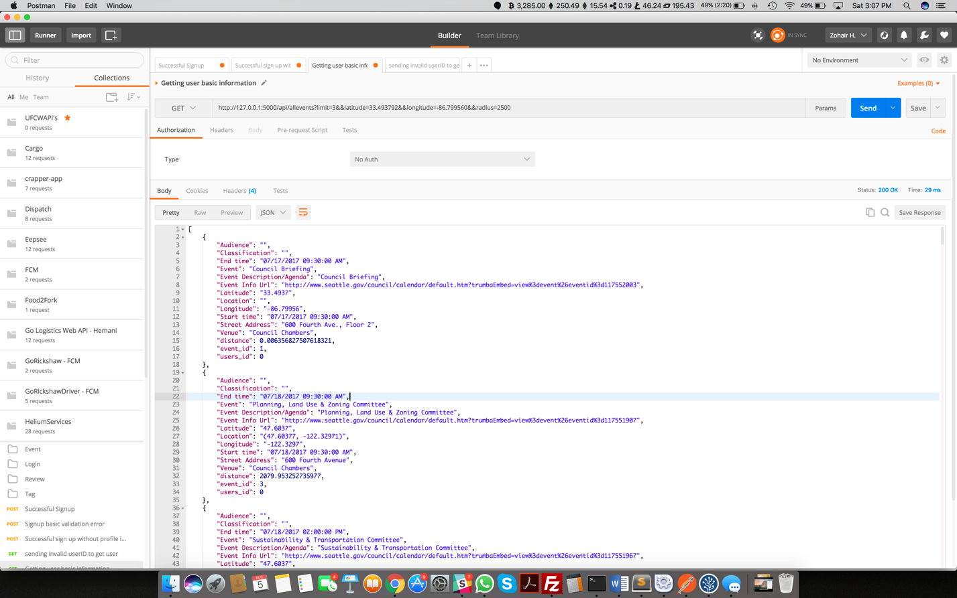

Limit: The limit variable limits the number of rows that the user wants to fetch in the API.

Latitude: User should send his latitude so he can calculate the nearby events within a certain radius

Longitude: User should send his longitude so he can calculate the nearby events within a certain radius

Radius: User can define a certain radius, and then the API will calculate the Euclidean distance between his location and the events location and then only fetch rows that are within that radius.